SWITCH AND ROUTER CONFIGRATION BASIC THEORY

TASK1: Log in to Cisco Packet Tracer or any network simulation tool, add a switch, and create two VLANs named 'Sales' and 'Support' with VLAN IDs 10 and 20.
- Opened Cisco Packet Tracer.
- Added one 2960 Switch to the workspace.
- Clicked on the switch and opened the CLI.
- Entered the following commands:
- enable
configure terminal
- vlan 10
name Sales
- vlan 20
name Support
- exit
The VLANs Sales (10) and Support (20) were created successfully.

TASK2: Assign three different switch ports to VLAN 10 (Sales) and two ports to VLAN 20 (Support), then verify the VLAN membership using the show vlan command.<br><br><em><strong>Hint:</strong> Use the interface range command to select multiple ports efficiently.</em>

ASSIGN PORTS TO VLAN 10(SALES)
enable
configure terminal

interface range fa0/1 - 3
switchport mode access
switchport access vlan 10
exit
ASSIGN PORTS TO VLAN 20(SUPPORT)
interface range fa0/4 - 5
switchport mode access
switchport access vlan 20
exit
VERIFY VLAN: show vlan brief

TASK3: Connect two routers using a serial or Ethernet link in your simulation tool, assign IP addresses to their interfaces, and configure a static route on Router 1 to reach the LAN behind Router 2.
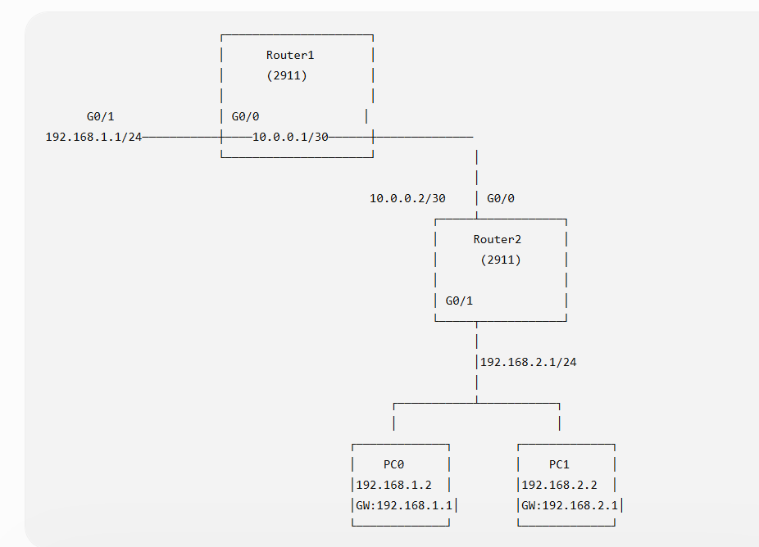

TASK4: Simulate a scenario where a device in the 'Sales' VLAN tries to ping a device in the 'Support' VLAN and explain why the ping fails, then suggest what configuration would allow inter-VLAN communication.<br><br><em><strong>Hint:</strong> Think about router-on-a-stick or Layer 3 switch concepts.</em>
OBSERVATION:
A PC in the Sales VLAN (VLAN 10) tried to ping a PC in the Support VLAN (VLAN 20).
The ping failed because VLAN 10 and VLAN 20 are separate broadcast domains. A Layer 2 switch cannot forward traffic between different VLANs.
To allow communication, Inter-VLAN Routing must be configured using:
- Router-on-a-Stick, or
- Layer 3 Switch
After configuring inter-VLAN routing, devices in different VLANs can communicate successfully.

